**A) Project Report: Bank Management System**

**1. Introduction**

**1.1 Background**

The Bank Management System is a software project developed in the C programming language. The system aims to provide basic banking functionalities such as account creation, user login, and exit options to users.

**1.2 Objectives**

The main objectives of the project include:

* Implementing a user-friendly interface for account creation.
* Providing a secure login system.
* Developing a simple menu-based system for user interaction.

**2. Scope**

The scope of the Bank Management System project encompasses(s) the following functionalities:

* Account Creation: Users can create new bank accounts by providing necessary details.
* User Login: Existing users can log in using their username and password.
* System Exit: Users can exit the system at any point.

**3. Methodology**

The project follows a procedural programming approach, utilizing the C language and standard libraries such as **conio.h**, **stdio.h**, **stdlib.h**, **string.h**, and **windows.h**. The program structure involves modular design, separating different functionalities into functions for clarity and ease of maintenance.

**4. Implementation**

**4.1 Account Creation**

The account creation process involves collecting user details, validating input, and storing information securely. The program utilizes data structures and file handling for persistent storage.

**4.2 User Login**

User login functionality requires username and password verification. Passwords are securely stored using appropriate encryption techniques, and access is granted upon successful verification.

### 4.3 System Exit

The program provides an option for users to gracefully exit the system, ensuring proper resource management and data integrity.

## 5. User Interface

The project features a text-based user interface with a menu-driven system. Users are prompted with options to choose from, facilitating easy navigation.

## 6. Conclusion

The Bank Management System project in C language successfully implements the desired functionalities, providing users with a basic yet effective banking solution. The modular design and user-friendly interface contribute to the project's overall success.

**7. Future Enhancements**

Possible future enhancements for the project include:

* Implementing additional banking features (e.g., fund transfer, transaction history).
* Enhancing security measures for user data protection.
* Developing a graphical user interface for a more modern and visually appealing user experience.

**8. Acknowledgments**

We would like to express our gratitude to the creators of the C programming language and the libraries used in this project.

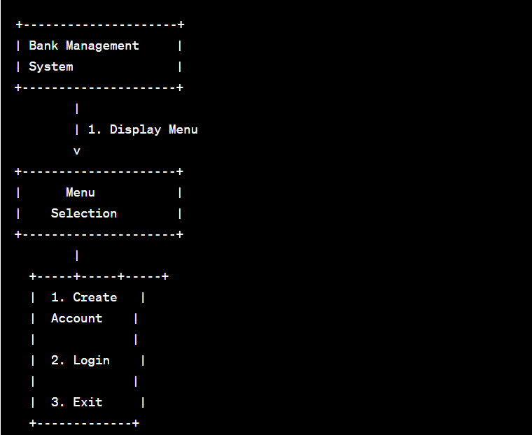

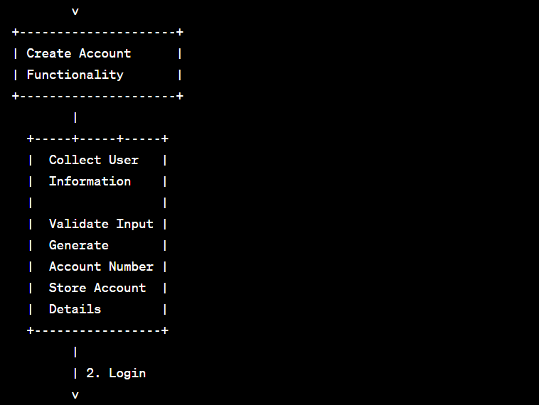

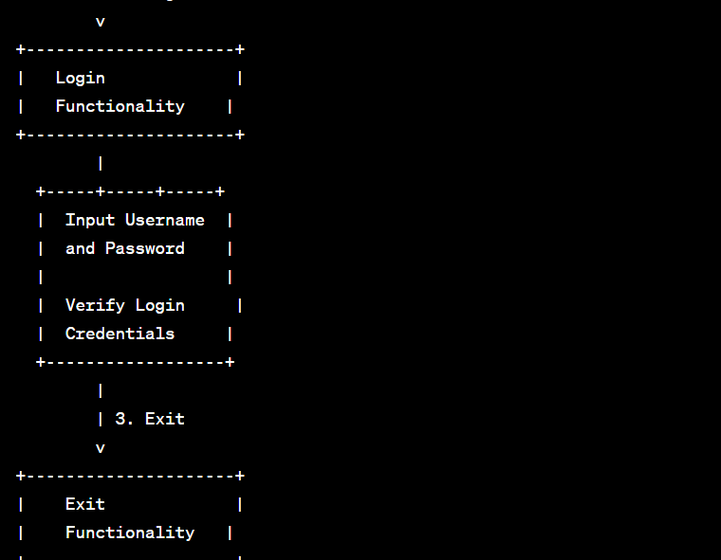

1. **Applications: Bank Management System**
2. **Small and Medium-sized Banks:**
   * Your Bank Management System can be deployed in small and medium-sized banks to automate and streamline their account creation and login processes.
   * It provides a basic yet effective solution for managing customer accounts and interactions.
3. **Educational Purposes:**
   * The project serves as an excellent educational tool for students learning C programming language and software development.
   * It can be used in programming courses to demonstrate file handling, user input validation, and basic menu-driven interfaces.
4. **Learning Security Concepts:**
   * The login system in your project provides a practical example for learning and understanding concepts related to user authentication and password security.
   * It can be used as a hands-on exercise to teach students about password hashing and encryption.
5. **Prototype for Larger Banking Systems:**
   * Your project can serve as a prototype or starting point for the development of more advanced banking systems with additional features.
   * It provides a foundation for incorporating features like fund transfers, transaction history, and account management.
6. **Coding Practice and Skill Development:**
   * Individuals looking to enhance their C programming skills can use your project as a practical coding exercise.
   * It helps developers practice file I/O, string manipulation, and menu-driven program design.
7. **Open Source Contribution:**
   * Consider open-sourcing your project on platforms like GitHub to allow other developers to learn from and contribute to the code.
   * This can foster collaboration and improvement of the project by a broader community.
8. **Training and Workshops:**
   * The project can be used in programming workshops and training sessions to teach participants about building simple software applications using C.
   * Workshops can focus on extending the functionality of the existing project or customizing it for specific use cases.

## PROJECT REPORT BY-

## RUPESH (22BTC35156)

## RONIT (22BTC35155)